Comparative Study of Countries

**Shubham Govind Behera**

**Steps to Perform:**

1. Create a geographic map showing the countries' fields. Color the map based on the income column from the secondary dataset
   1. Include income group filter in the dashboard

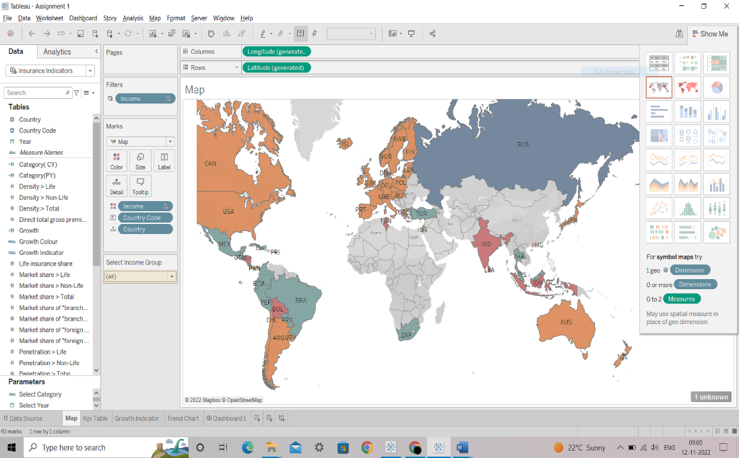

1. Create a KPI Table to show the comparison between the selected period and the period prior to the selected one
   1. Create two parameters for Year Selection and Category Selection
   2. Category parameter includes life insurance share, market share, penetration, ratio of reinsurance accepted, and retention ratio
   3. Create a calculated field to calculate the Growth %
   4. Create a table to show these values
   5. Title should be updated based on the category selection

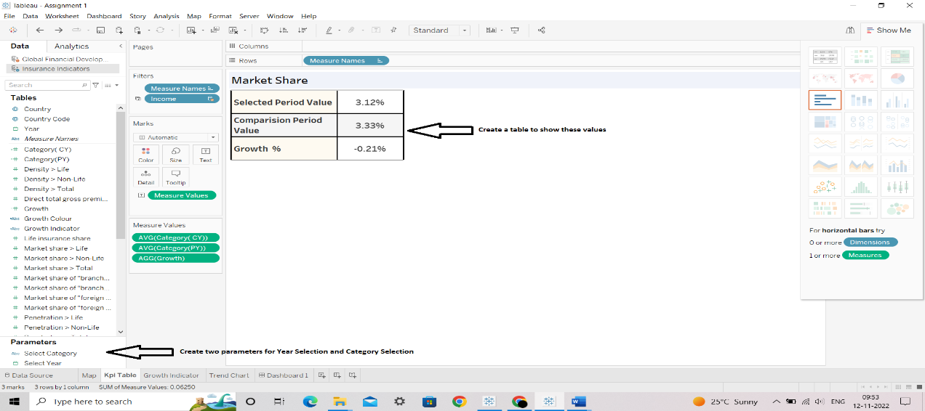

1. Create Growth Indicator Shapes based on the Growth %
   1. Growth indicator displays Negative, No Change, and Positive as values and corresponding shapes against it

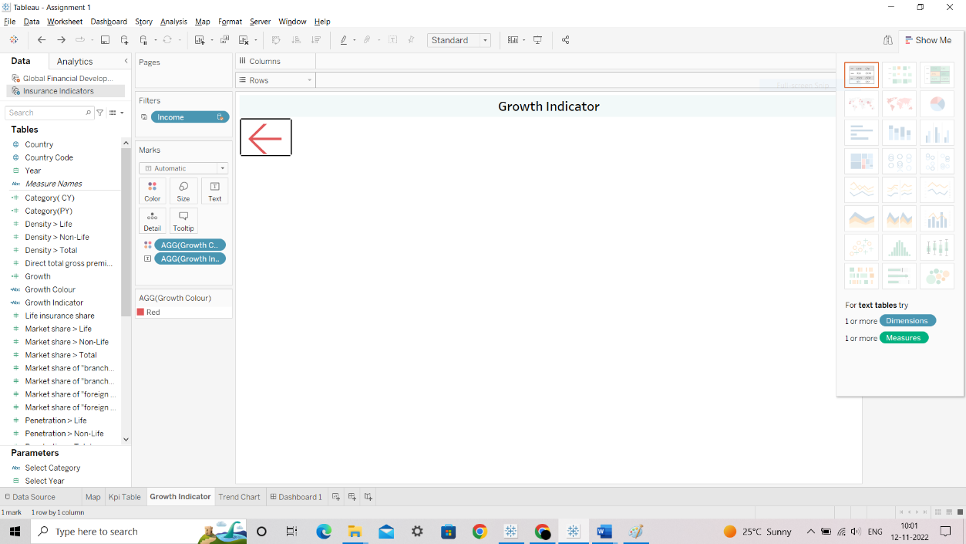

1. Create a trend line to show the selected category values
   1. The line shows an arrow or triangle at the last mark

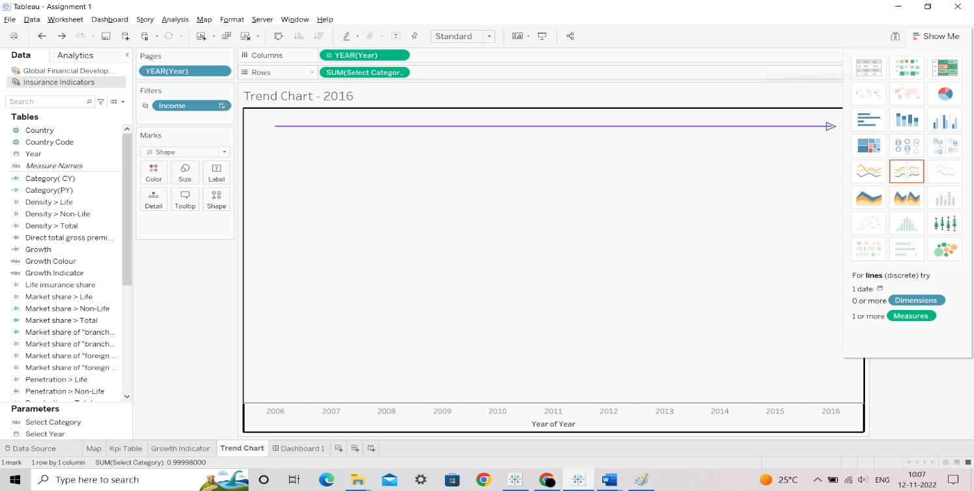

1. Include a webpage to show data from the world bank webpage driven by an URL action from a geography graph
   1. The country names in the map will act as the trigger

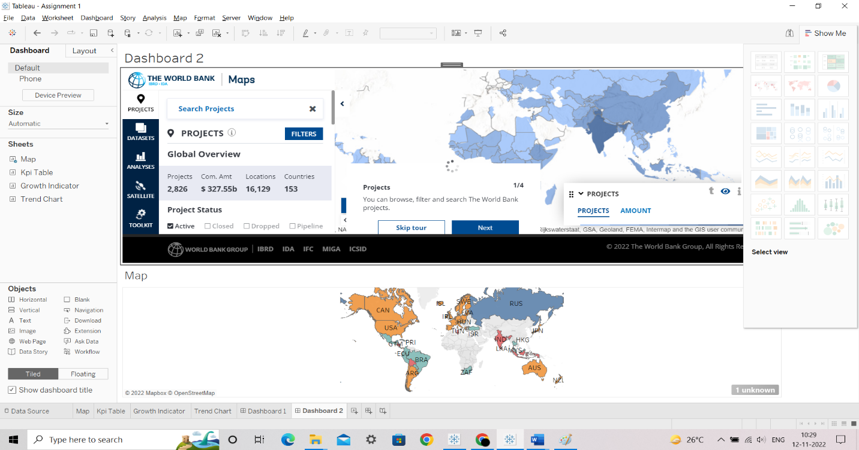

1. Create a dashboard filter for income group to be applied for all charts with the filter action enabled in the map as well

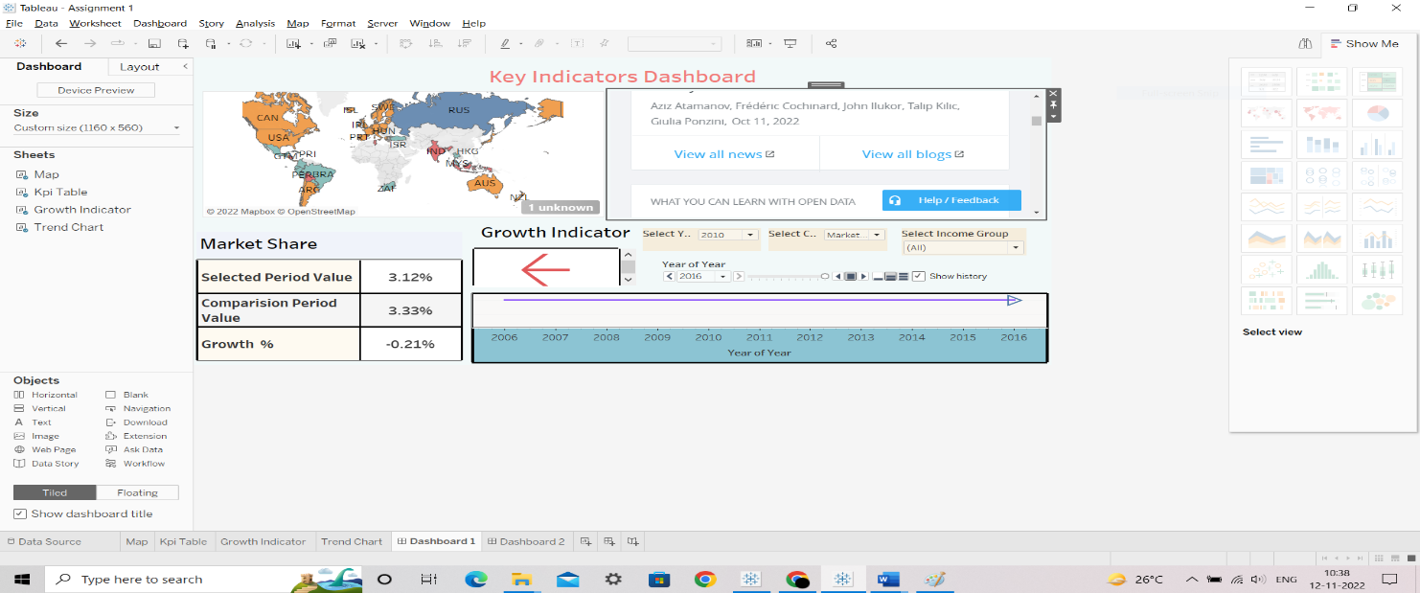

1. Create a dashboard filter for income group to be applied for all charts with the filter action enabled in the map

as well

